- Purpose

The purpose of this procedure is to describe the maize grading procedure as per EAS 2:2017 Maize Grains Specification, and EAS 900:2017 Cereals & Pulses – Test Methods.

- Scope

The procedure covers only maize grading.

- Responsibilities

The trained quality analysts have the responsibility of ensuring that all grains are graded correctly according to this procedure.

- Definitions

- Maize (corn): The shelled grains of species Zea mays indentata L. (dent maize) and/or Zea mays indurata L. (flint maize), or their hybrids.
- Damaged grains: grains which are insect or vermin injured, stained, diseased, discoloured, germinated, or otherwise materially damaged.
- Foreign matter: all organic and inorganic material (such as sand, soil and glass) other than maize, broken kernels and other grains.
- Broken kernels: pieces of maize which shall pass through a 4.50 mm metal sieve.
- Diseased grains: grains made unsafe for human consumption due to decay, moulding or bacterial decomposition, or other cause that may be noticed without having to cut the grains to examine them.
- Discoloured kernels: kernels materially discoloured by excessive heat, including that caused by excessive respiration (heat damage) and dried damaged kernels. Kernels may appear darkened, wrinkled, blistered, puffed and swollen often with discoloured damaged germs. The seed coat may be peeling or may have peeled off completely, giving kernels a checked appearance.
- Defective grains: pest damaged, discoloured, diseased, germinated, mouldy, immature and shrivelled grains, or otherwise materially damaged, which specifically do not include broken grains.

- Tasks and Procedures

  - Equipment and Devices

Grading as per this procedure requires:

Equipment | Picture
4.5 mm round sieve with a bottom pan | 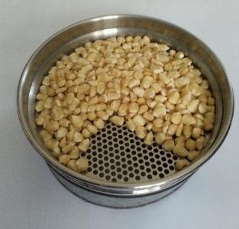
A riffle or Boerner divider | 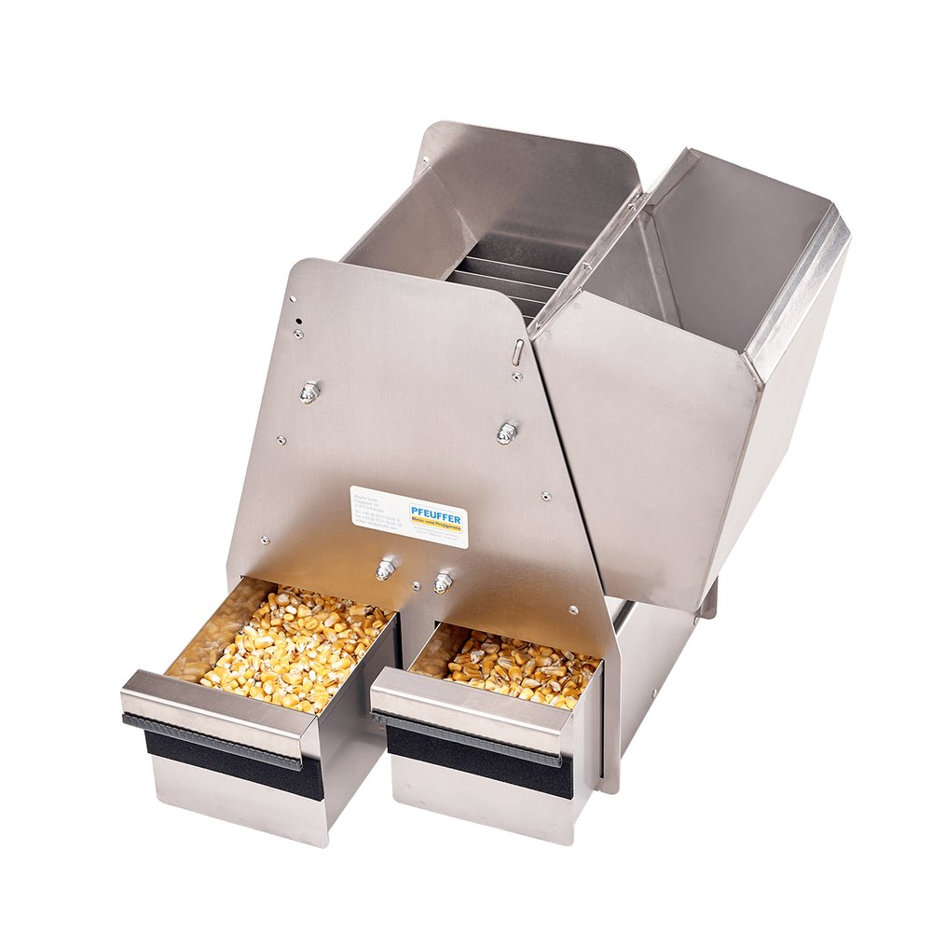
A calibrated moisture meter | 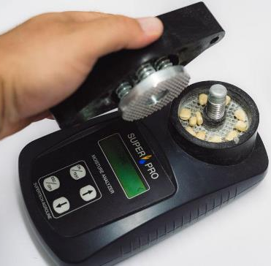
A calibrated weighing scale (0.00 g – 1,000.00 g) | 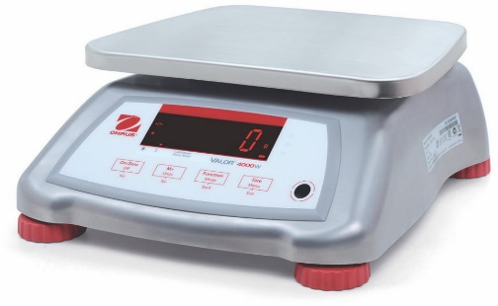
Weighing Tin | 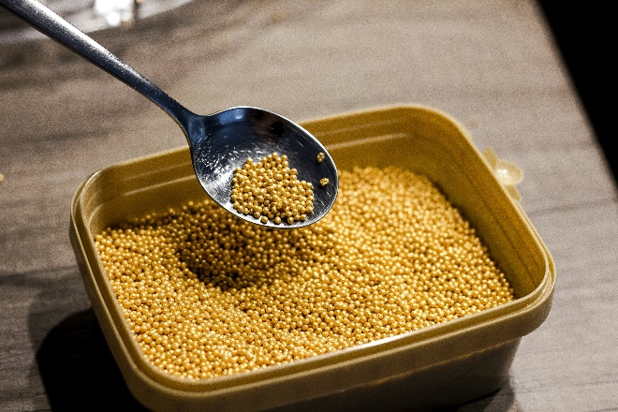

  - Grading Requirements
Before grading, confirm that the equipment, method and operator meet the readiness requirements summarised below:
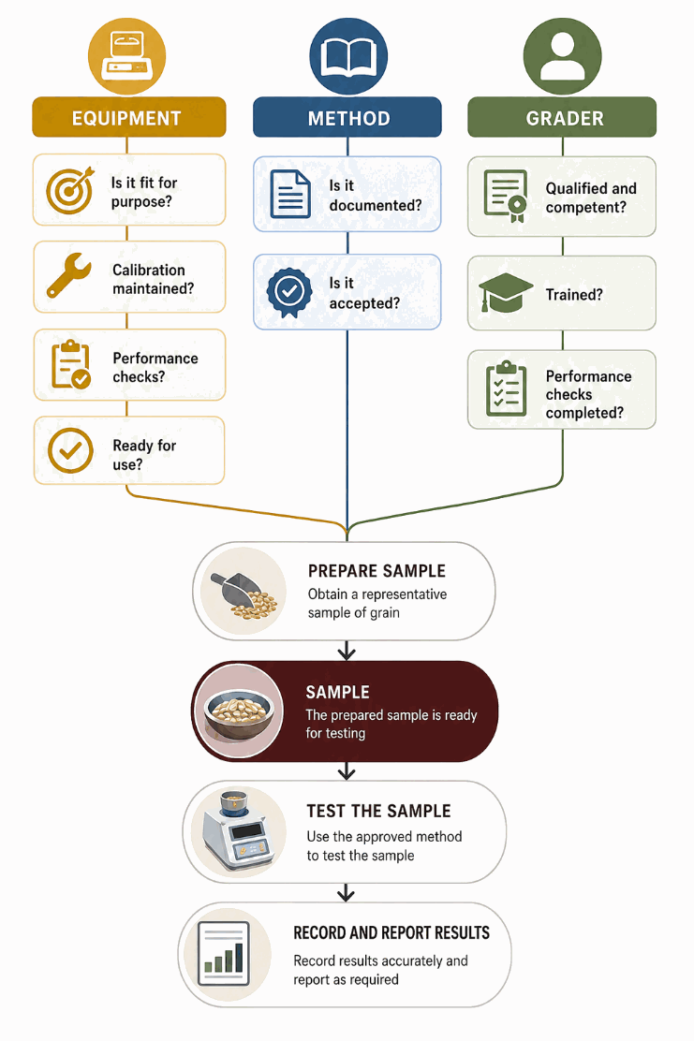
  - Grading Process

    - Visual and Organoleptic Test
These are tests that are conducted using senses of sight, smell, and taste. Maize for human and animal consumption should be free from foreign odours, moulds, live pests, rat droppings, toxic or noxious weed seeds and other hazardous contaminants.

To check for this, obtain a representative sample of the grain. Use the senses of sight and smell to check the existence of these defects. This test is normally the first to be done. Other tests will follow if the maize passes this test. This test can easily be conducted in the field because it does not require any equipment.

    - Testing for Foreign Odour
- Obtain a representative composite sample.
- Spread out the sample on a flat surface and smell it.
- The smell should be typical of maize without other smells e.g. chemicals, mouldiness, earthy, rotten, musty smell, etc.
Any grain with objectionable odour should be rejected.
    - Testing for Presence of Visible Infestation
- Obtain a representative sample.
- Spread about 100 grams of the sample on a warm plate (at 40 ˚C).
- Cover the plate with a glass jar (bell glass jar if possible) to prevent the insects from escaping.
- After 15 minutes, sieve the grain through an appropriate sieve, e.g. a 4.5 mm round sieve.
- Check for living insects, dead insects and insect larvae.
- Using a scalpel, cut across maize kernels that are insect damaged, to check for live or dead insects (primary pests) harbouring in the grain.
- Note the presence of rodent droppings.
Reject the grain if it has one or more live insects.
    - Determination of Moisture Content
- To determine moisture content using moisture meters, follow the manufacturer’s instructions.
- Ensure that the moisture meters are maintained and calibrated regularly to get accurate results.
- Avoid touching samples with bare hands.
    - Determination of Foreign Matter
- Place a clean, dry basin (bottom pan) in position to receive any materials that may go through the sieve.
- Weigh 200 grams of the representative sample (${Weight}_{1}$)
- Put the maize in the sieve provided (4.5 mm round hole).
- Shake the sieve horizontally 30 times for about 15 seconds.
- Collect all the foreign organic matter that has passed through the sieve.
- Handpick all foreign organic matter retained on top of the sieve.
- Weigh all the foreign matter collected from the bottom pan and that handpicked from the top (${Weight}_{2}$)
Foreign matter = | $$\frac{{Weight}_{2}}{{Weight}_{1}}*100$$

    - Determination of Inorganic Matter
These are foreign materials of non-biological origin e.g., metals, stones, glass, plastic, soil, sand, dust etc.
- From step 5.3.5 above
- Sort out all metallic matter, stones, plastics, glass, or sand, etc.
- Weigh the inorganic matter (${Weight}_{2}$)
- Express the results as a percentage over ${Weight}_{1}$
Inorganic Matter = | $$\frac{{Weight}_{2}}{{Weight}_{1}}*100$$

    - Determination of Broken Grains
- From step 5.3.5 above
- Collect all the whole and broken grains that passed through a 4.5 mm round-hole sieve.
- Weigh the broken grain (${Weight}_{2}$)
- Express the percentage of broken maize as follows:
Broken Grain = | $$\frac{{Weight}_{2}}{{Weight}_{1}}*100$$

    - Determination of Pest-Damaged Maize
From the sample remaining on top of the sieve in step 5.3.5 above:
- Pour maize on a bench/working surface.
- Pick the pest damaged grain kernels by hand.
- Weigh the pest damaged grain (${Weight}_{2}$)
- Express the percentage insect damaged grains as:
Pest Damaged Grain = | $$\frac{{Weight}_{2}}{{Weight}_{1}}*100$$

    - Determination of Rotten and Diseased Grains
From the sample remaining on top of the sieve in step 5.3.5 above:
- Pick the rotten and diseased grains by hand.
- Weigh the rotten or diseased maize grains (${Weight}_{2}$).
- Express the percentage rotten and diseased grains as:
Rotten and Diseased Grain = | $$\frac{{Weight}_{2}}{{Weight}_{1}}*100$$

    - Discoloured Grains
From the sample remaining on top of the sieve in step 5.3.5 above:
- Pick the discoloured grains by hand (taking care not to include other coloured maize). Discolouration must be >25% of the grain kernel on one side.
- Weigh the discoloured grains (${Weight}_{2}$).
- Express the percentage discoloured grains as:

Discoloured Grain = | $$\frac{{Weight}_{2}}{{Weight}_{1}}*100$$

    - Immature/Shrivelled Grains
From the sample remaining on top of the sieve in step 5.3.5 above:
- Pick the immature/shrivelled grains by hand.
- Weigh the immature/shrivelled grains (${Weight}_{2}$).
- Express the percentage immature/shrivelled grains as:

Immature Grain = | $$\frac{{Weight}_{2}}{{Weight}_{1}}*100$$

    - Filth
- From the working sample weighed in 5.3.5 above (200 grams) (${Weight}_{1}$)
- Collect all the filth that went through the sieve and that which remains on top.
- Weigh the filth (${Weight}_{2}$)
- Estimate the percentage filth level as:
Filth = | $$\frac{{Weight}_{2}}{{Weight}_{1}}*100$$

    - Total Defective Grains
This refers to the total sum of the grain kernel defects obtained above (steps 5.3.8 to 5.3.11, i.e. pest damaged, rotten and diseased, discoloured, and immature/shrivelled kernels). Broken grains, foreign matter and filth should not be included in this summation.
- Put together all defective grains in steps 5.3.8 to 5.3.11 above by hand (diseased, discoloured, stained, immature/shrivelled, pest damaged, etc.)
- Weigh them (${Weight}_{2}$)
- Express the percentage total defective grains as:
Total Defective = | $$\frac{{Weight}_{2}}{{Weight}_{1}}*100$$

- Assigning of Grades
- Fill in a grading sheet (see sample in Appendix 1).
- Compare each defect percentage against the standard limit.
- If all the defects and the total defective grains fall within the limits for a grade, assign that grade.
- If any one defect is above the specified limit for a grade, or the total defective grains exceed the specified limit, then the next grade is applied.

- References
- ISO 24333:2009 Cereals and cereal products – Sampling.
- EAS 2:2017 Maize grains – Specification.
- EAS 900:2017 Cereals and pulses – Test methods.

APPENDIX 1: Grading Sheet Sample

