- Purpose
This document establishes procedures for sampling grain for the purpose of mycotoxin contaminant testing.
Sampling is the most important step in the process of detecting aflatoxin. This is because aflatoxin presence in grains is highly skewed (not homogenous) often resulting in high sampling errors i.e., only one of few grains in the entire lot may be enough to cause the entire lot to fail.
- Reference
Reference: ISO 24333 (First edition: 2009-12-15) Cereals and cereal products — Sampling
- Scope
This procedure specifies requirements for the dynamic or static sampling, by manual or mechanical means, of cereals and cereal products, for assessment of their quality and condition.

This procedure is applicable to sampling for the determination of heterogeneously distributed contaminants, undesirable substances, and parameters usually homogeneously distributed like those used to assess quality or compliance with specification.
- Definitions
- Increment [or, Primary] sample: amount of material taken at one time at each individual sampling point throughout a lot
- Aggregate [or, Composite] sample: aggregation of two or more increments, taken by sampling throughout a lot, combined and homogenized
- Laboratory sample: sample prepared by homogenizing and dividing an aggregate sample for sending to the laboratory and intended for inspection or testing
- Retention sample: means a sample kept for future analysis (e.g. when disputes arise).
- Working sample: A subset of the laboratory sample which is actually used during the test.
- Lot: identified quantity of material (cereal or cereal product) from which a sample can be taken and controlled to determine one (or several) characteristic(s)

- Main Sampling Principles
Whenever possible, sampling should be carried out when the products are flowing/moving (e.g. during loading or unloading) so that all the constituent parts of the lot have the same probability of being sampled. Sampling of static grain (e.g., on a stack in the warehouse or in a truck) may pose challenges to access the full lot, and therefore any sample obtained may not be representative of the entire lot.

  - Determining sampling frequency of bagged grain in a truck/store:
If possible, sample grain while being loaded or offloaded from the truck/store.
- Range of increments: 100g – 400g (depending on the sampling equipment)
- Minimum aggregate sample: 4kg
- Determining the number of bags to be sampled:
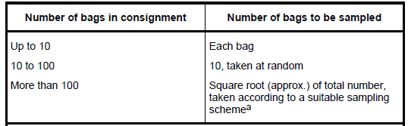
- Determining Sampling Frequency (sample increment every “y” number of bags)

$$F\left(n\right)=\frac{mB mI}{mA mP}$$

Where:
mB = mass (kg) of a consignment
mI= mass (kg) of each increment
mA= mass (kg) of the aggregate sample [i.e. ≥ 4kg if for aflatoxin determination
mP = mass (kg) of the individual bag (or package).

Example:
A truck is carrying 28,000 kg of grain in 50 kg bags and needs to be sampled. You have a sampling spear that is able to draw 100g (0.100 kg) each time. Then, the frequency of sampling is:

$$F\left(n\right)=\frac{28,000kg x 0.100kg}{4kg x 50kg}$$

= 14 (i.e. take one sample after every 14 bags)

  - Determining Sampling Frequency of flowing bulk grain
Sampling of flowing bulk grain is done for moving grains e.g. on conveyor belts, discharge spouts, etc.
The sampling frequency should be determined by the speed of the flowing grain.

Requirements:
- Range of increments: 400g – 3,000g depending on the type of sampling equipment used
- Number of increments: 20 per lot/sublot for any lot up to 500 tons
- To determine how many increments to be taken per a certain duration:
$$y= \frac{i}{t} x F$$
Where:
y. = Number of increments per certain duration e.g. per hour
i = Number of required increments
t = Tonnage of the lot/sub-lot
F = Flow Rate (Tons per hour)

Example:
The procedure specifies obtaining 20 increments per lot for any lot ≤500 tons. You are sent to sample 500 tons of grain in a handling facility where the grain flow rate is 50 tons per hour.

Solution:

$$y= \frac{20}{500} x 50=2 increments every 1 hour$$

(Or 1 increment every 30 minutes)

  - Sampling of Bulk Static Grain
Bulk static grains include bulk grain in trucks, silos or warehouses, ships, etc. It is recommended to use mechanical sampling systems where possible.

Requirements:
- Range of Increments: 400 – 3000 grams depending on the sampling equipment
- Minimum aggregate sample: 4kg subject to the sampling plan below

Lot size (m) | Minimum Number of Increments | Sampling Point Distribution  (for trucks/wagons, etc.)
m ≤ 15t | 5 sampling points | 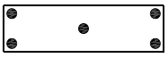
15 < m ≤ 30t | 8 sampling points | 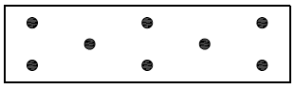
30 < m ≤ 45t | 11 sampling points | 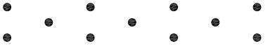
45 < m ≤ 100t | 15 sampling points | Likely to be in storage/vessel (not trucks/wagons)
100 < m ≤ 300t | 18 sampling points | Likely to be in storage/vessel (not trucks/wagons)
300 < m ≤ 500t | 20 sampling points | Likely to be in storage/vessel (not trucks/wagons)
500 < m ≤ 1,500t | 25 sampling points | Likely to be in storage/vessel (not trucks/wagons)

  - Sampling Equipment
There are many types of sampling equipment appropriate for different types of sampling activities. This procedure is limited only to the types that will be used to sample bagged maize in trucks/stores and bulk products in trucks.

    - Equipment for sampling bagged coarse grains
- Tapered sampling probe/trier/spear
- Minimum diameter: 25mm
- Aperture: 40mm by 25mm
- Length: 40 – 45 cm

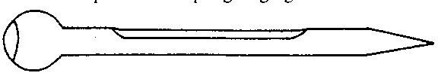

    - Equipment for sampling bulk coarse grains in a truck
- Double tube sampling spear
These spears comprise two metal tubes, one fitting closely inside the other and each with several common slots. Spears may vary in length from 45cm to 3.5m, and in width from 12mm to 50mm. Turning the inner tube through 180° opens or closes the intake apertures, and so collects grain from a transverse section of the bag.

- Pneumatic grain sampler
Pneumatic grain samplers are better than manual samplers. They use powered-suction to penetrate the static bulk of grain, and by taking a continuous sample. They are quicker to operate than manual samplers
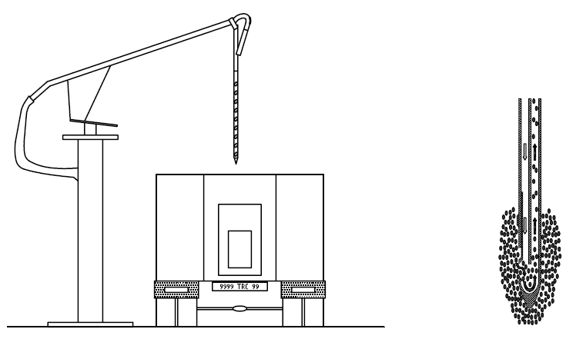

    - Sampling equipment of flowing grain e.g. during offloading, in conveyor belts or spouts
- Pelican Sampler
A Pelican sampler consists of a cowhide pouch attached to a metal frame at the end of a hardwood or tubular metal handle. It is used to obtain samples from freefalling grain, e.g. from a spout discharge, or during grain offloading.

Ensure to move the sampler through the stream from one side to the other in a single motion to obtain a good sample.

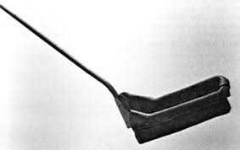

- Ellis Cup sampler
This is a hand-held scoop designed for obtaining small samples from bulk grain on moving conveyor belts. This is a hazardous process and should be avoided where possible. Pelican samplers are preferable for this reason.

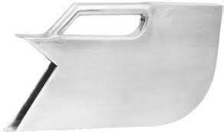

- Lab Sample
  - Aggregate sample size
Preferably, an aggregate sample of at least 4 kg should be obtained.
  - Homogenization
The aggregate sample (i.e. all increment samples put together) shall be thoroughly homogenized prior to milling of the sample from which the working sample for analysis will be obtained.
  - Packaging of samples
Laboratory samples shall be placed in clean containers. The containers shall be suitable for the 4kg of the laboratory samples. The containers shall also preserve the initial characteristics of laboratory samples. These containers shall be completely full and shall be sealed to avoid any change in their contents. Seals shall be tamper-proof and identifiable.
  - Labels for samples
The information listed below shall be marked indelibly and legibly. The information on the labels on the laboratory sample shall include the instructions required under the terms of the contract, for example:

- Maize grains
- 4kg
- Lot identifier
- Farmer/Trader Name
- Sampling date
- Location and point of sampling
- Name of the person who carried out the sampling
  - Shipment of samples
Samples should be sent to the laboratory as quickly as possible. The samples should be stored and transported in conditions appropriate to the preservation of their integrity.
- References:
- ISO 24333: 2009: Cereals and cereal products – Sampling
- Sample Preparation for Aflatoxin Testing – [add procedure reference #]
- FGIS, 2015. Mycotoxin Handbook

